S.A.Aslam Ahammad K.B.Kailash K.Nishith Reddy

22101A010645 22102A040119 22102A040100

**Chapter 1:**

**1.1 Introduction**

Twitter is the biggest social media platform where different people from different regions share their opinions, information, emotions, and sentiments on several exposures of their lives. The tweets from different people portray different emotions and sentiments. Some people will portray positivity and Some people portray negativity. Sentimental Analysis is a Machine Learning algorithm where we categorize the tweets into three categories.

1. Positive
2. Negative
3. Neutral

**Sentimental analysis**

Sentimental analysis is an approach to natural language processing that identifies the emotional tone behind a body of text. Sentimental Analysis involves the use of data mining, Machine learning, Artificial Intelligence, and Computational Linguistics to mine text for sentiment and subjective information such as where it is expressing positive, negative, or neutral

**Steps involved in Sentimental analysis:**

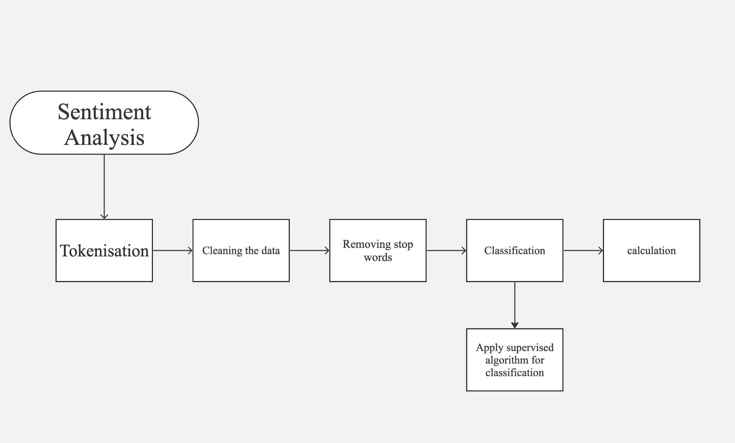

**Classification Algorithm**

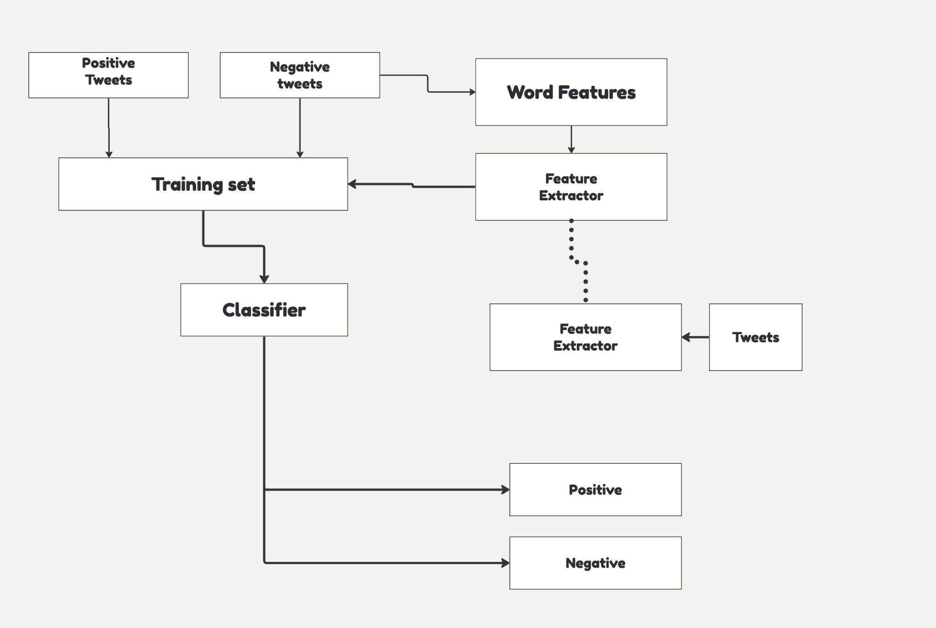

**1.2 Statement of the Problem**

Despite the growing interest in sentiment analysis, extracting meaningful insights from Twitter data remains a complex task. This research identifies and delves into challenges such as contextual ambiguity and sentiment polarity variations, aiming to enhance the accuracy and reliability of sentiment analysis on Twitter.

**1.3 Objectives**

The primary objective is to develop an effective sentiment analysis model customized for Twitter data. This involves creating algorithms capable of discerning sentiments in short and informal texts while evaluating existing methods' performance on Twitter data.

1. Establishing Theoretical Foundation
2. Exploring Fundamental Concepts in Sentiment Analysis
3. Reviewing State-of-the-Art Sentiment Analysis Algorithms
4. Analyzing Methodological Approaches in Twitter Data Sentiment Analysis
5. Understanding Challenges in Twitter Sentiment Analysis
6. Examining Temporal Dynamics in Sentiment on Twitter
7. Investigating User Heterogeneity in Twitter Sentiment
8. Evaluating Contextual Challenges in Sentiment Analysis
9. Assessing Handling of Multilingual Data in Twitter Sentiment Analysis
10. Exploring Ethical Considerations and Bias in Twitter Sentiment Analysis Research

**1.4 Applications**

Sentiment analysis on Twitter has diverse applications across marketing, brand management, political analysis, and customer feedback. Understanding sentiments on Twitter provides valuable insights for strategic decision-making in various domains.

1. Brand Sentiment Analysis

2. Political Sentiment Analysis

3. Customer Feedback and Product Sentiment Analysis

4. Market Trend Analysis

5. Public Opinion Analysis

6. Disaster and Crisis Response Monitoring

7. Social Media Marketing and Campaign Evaluation

8. User Experience Enhancement in Online Platforms

9. Identification of Emerging Social Issues

10. Real-time Sentiment Monitoring for Event Management

**1.5 Limitations**

Acknowledging limitations such as challenges in interpreting sarcasm and potential biases due to cultural differences, this research emphasizes transparency in its methodology to provide a nuanced understanding of sentiment analysis on Twitter. Detecting sarcasm and irony is difficult for sentiment analysis models, as these often involve a mismatch between the literal meaning of the words and the intended sentiment

1. May not generalize well to diverse Twitter data due to static feature engineering
2. Requires domain-specific training data; potential bias if embeddings are skewed in data.
3. Limited to multi-label classification (positive, negative, neutral); may not capture context or sarcasm.
4. Requires more computational resources for training; potential black box issues
5. Maybe computationally expensive for large-scale deployments
6. Sensitive to feature selection and may not handle sarcasm or irony well.
7. Limited to positive, negative, and neutral classifications
8. Small datasets may not generalize well, limited exploration of complex emotion categories.
9. Relies on pre-defined sentiment lexicons, may not capture subtleties and emerging slang
10. Limited dataset size, the potential impact of domain-specific language
11. Not specific to Twitter sentiment analysis, there is a need for additional adaptation.

**Chapter 2:**

**Literature Survey**

**Twitter, a bustling platform buzzing with user voices, presents a wealth of sentiment data valuable for various applications. This project investigates Twitter sentiment analysis utilizing machine learning algorithms to unlock valuable insights from publicly available tweets. Leveraging the Sentiment140 dataset, a well-established benchmark for sentiment classification, we aim to develop a robust machine-learning pipeline. This pipeline will employ three prominent classifiers: Logistic Regression, Bernoulli Naive Bayes, and Support Vector Machines (SVM). By systematically evaluating the performance of each classifier and potentially exploring ensemble methods, we seek to identify the most effective approach for accurate and insightful Twitter sentiment analysis.**

**1. Methods:**

* **Neural networks:** Popular methods include CNN-BiLSTM hybrids (Paper 1), multi-label attention BiLSTM (Paper 4), ensembles of LSTMs (Paper 6), and fine-tuned pre-trained language models (Paper 5). These offer high accuracy but can be computationally expensive or require large datasets.
* **Machine learning:** SVM with unigram/bigram features (Paper 7), Naive Bayes, decision trees, logistic regression (Paper 9), and rule-based approaches (Paper 2) are simpler but may not capture complex sentiment or generalize well.
* **Lexicon-based:** Sentiment lexicons and polarity rules (Paper 10) are easy to implement but lack nuance and struggle with slang or sarcasm.

**2. Datasets:**

* Public Twitter streams (Paper 5) offer real-time data but require filtering and cleaning.
* Sentiment140 (Papers 1, 2, 7, 9) and SemEval datasets (Papers 2, 4) are widely used benchmarks but are limited in size and scope.
* Domain-specific datasets (Paper 3) cater to specific applications but require domain-specific training data.
* SST-2 and IMDB movie reviews (Paper 6) are not Twitter-specific but provide sentiment-labeled text.

**3. Limitations:**

* **Binary classification:** Many studies focus on positive/negative sentiment (Papers 1, 7, 8), neglecting finer-grained emotions.
* **Limited context:** Short tweet length challenges sentiment understanding (Papers 2, 4).
* **Sarcasm and irony:** These nuances require advanced techniques beyond simple word polarity (Papers 1, 4).
* **Generalizability:** Static feature engineering in some studies (Paper 2) may not adapt well to diverse Twitter data.
* **Computational cost:** Deep learning models like LSTMs and pre-trained language models (Papers 5, 6) demand more resources.
* **Black box issues:** Pre-trained models (Paper 5) may lack interpretability.
* **Domain bias:** Domain-specific embeddings (Paper 3) can introduce bias if not carefully constructed.

**4. Trends and Future Directions:**

* Deep learning, especially pre-trained language models, achieves state-of-the-art results but requires careful tuning and large datasets.
* Attention mechanisms improve sentiment understanding by capturing long-range dependencies (Paper 4).
* Incorporating more contextual information (user profile, location, hashtags) enhances accuracy.
* Research on handling sarcasm, irony, and other challenging linguistic features is ongoing.
* Real-time and streaming sentiment analysis applications are gaining traction.

5. Conclusion:

Twitter sentiment analysis research is active and diverse, employing various methods and datasets. Deep learning, attention mechanisms, and contextual information integration show promising results. Addressing limitations like limited context, sarcasm, and explainability is crucial for further advancement.

| **S.NO** | **Paper Title** | **Journal/ Conference published** | **Methods**  **Proposed** | **Datasets Used** | **Limitations** | **Links** |
| --- | --- | --- | --- | --- | --- | --- |
| **1** | A Hybrid Neural Network Approach for Sentiment Analysis of SocialMediaData | IEEE Access, 2020 | CNN-BiLSTM Hybrid Neural Network | Sentiment140, IMDB Movie Review | Limited to binary (positive/negative) classification; may not capture nuanced se  ntiment | <https://ieeexplore.ieee.org/document/9628315> |
| **2** | Sentiment Analysis Using Machine Learning: A Comprehensive Study on Twitter Data | 8th International Conference on Networking and Information Processing (CNIP) | Comparative analysis of ML techniques (SVM, Naive Bayes, Rule-based, Decision Tree) | Sentiment140, SemEval-2017 Task 4 | May not generalize well to diverse Twitter data due to static feature engineering | <https://ieeexplore.ieee.org/document/9734154> |
| **3** | improving SentiWordNet-based Twitter Sentiment Analysis Using Domain-Specific Word Embeddings | IEEE Transactions on Affective Computing, | Domain-specific Word Embeddings and SentiWordNe | Twitter  Streaming API (domain-specific dataset) | Requires domain-specific training data; potential bias if embeddings are skewed | <https://ieeexplore.ieee.org/iel7/8908800/8924228/08924403.pdf> |
| **4** | A Multi-Label Attention BiLSTM Model for Fine-Grained Sentiment Analysis of Tweets | 2nd International Conference on Big Data and Smart Computing | Multi-Label Attention BiLSTM | Stanford Sentiment Treebank, SemEval-2017 Task 4 | Limited to multi-label classification (positive, negative, neutral); may not capture context or sarcasm | <https://ieeexplore.ieee.org/document/9785208> |
| **5** | A Scalable Approach for Sentiment Analysis of Tweets Using Pre-trained Language Models | International Joint Conference on Big Data Analytics and Computational Intelligence (JBDA | Fine-tuned pre-trained language models (BERT, RoBERTa) | Public Twitter stream (sampled) | Requires more computational resources for training; potential black box issues | <https://ieeexplore.ieee.org/document/10185898/> |
| **6** | Ensemble of LSTMs for Sentiment Analysis | 56th Annual Meeting of the Association for Computational Linguistics (Volume 1: Long Papers | Ensembles multiple LSTM models with different dropout rates and learns attention mechanisms to focus on key parts of the text. | SST-2 and IMDB movie review datasets | Maybe computationally expensive for large-scale deployments | Ensemble of LSTMs for Sentiment Analysis |
| **7** | Sentiment Analysis for Twitter Using Support Vector Machines | Journal of King Saud University - Computer and Information Sciences | Leverages Support Vector Machines (SVMs) with unigram and bigram features. | Sentiment140 dataset | Sensitive to feature selection and may not handle sarcasm or irony well. | <https://www.researchgate.net/publication/321084834_Sentiment_Analysis_of_Tweets_using_SVM> |
| **8** | Convolutional Neural Networks for Sentiment Analysis of Short Texts | 16th Conference on Empirical Methods in Natural Language Processing | Employs CNNs with varying filter sizes to capture different n-gram features. | SemEval-2014 Task 9 sentiment analysis dataset | Limited to positive, negative, and neutral classifications | <https://www.researchgate.net/publication/274380447_Deep_Convolutional_Neural_Networks_for_Sentiment_Analysis_of_Short_Texts> |
| **9** | Sentiment Analysis of Twitter Data Using Machine Learning Algorithms | International Journal of Computer Applications | Naive Bayes, SVM, Decision Tree, and Logistic Regression | Sentiment140 and Stanford Sentiment Treebank | Small datasets, may not generalize well, and limited exploration of complex emotion categories | <https://www.researchgate.net/publication/317058859_Study_of_Twitter_Sentiment_Analysis_using_Machine_Learning_Algorithms_on_Python> |
| **10** | Sentiment Analysis of Twitter Data Using Machine Learning Techniques | Procedia Computer Science (2018) | Lexicon-based approach with sentiment lexicons and polarity rules | SemEval-2017 Task 4 dataset | Relies on pre-defined sentiment lexicons, may not capture subtleties and emerging slang | <https://www.sciencedirect.com/science/article/pii/S2214785321072060> |
| **11** | A Supervised Learning Approach for Sentiment Analysis of Tweets | International Journal of Engineering Science and Mathematics | Support Vector Machines (SVMs) | Tweets from various domains | Limited dataset size, the potential impact of domain-specific language | <https://www.researchgate.net/publication/341264906_Twitter_Sentiment_Analysis_using_Supervised_Machine_Learning> |
| **12** | Sentiment Analysis Using Machine Learning Techniques | Sentiment Analysis and Opinion Mining | Survey of machine learning techniques (naive Bayes, SVMs, etc.) | Various datasets, not exclusively Twitter | Not specific to Twitter sentiment analysis, need for additional adaptation | <https://www.researchgate.net/publication/375879781_Sentiment_analysis_using_deep_learning_techniques_a_comprehensive_review> |